Implementation of DES (Data Encryption Standard)
Aim
To implement the Data Encryption Standard (DES) algorithm in C for encrypting and decrypting a given plaintext using a secret key.

Algorithm
Encryption
- Start.
- Read the plaintext from the user.
- Read the encryption key.
- Convert the plaintext into binary representation.
- Generate the 16 round keys from the given key.
- Perform the Initial Permutation (IP) on the plaintext.
- Split the plaintext into two equal halves (Left and Right).
- Repeat the following for 16 rounds:
  - Expand the Right half.
  - XOR it with the round key.
  - Apply S-Box substitution.
  - Perform P-Box permutation.
  - XOR the result with the Left half.
  - Swap the Left and Right halves.
- Combine the two halves.
- Perform the Final Permutation (FP).
- Display the ciphertext.
- Stop.
Decryption
- Read the ciphertext.
- Use the same 16 round keys in reverse order.
- Perform the same DES rounds.
- Obtain the original plaintext.
- Display the decrypted text.
- Stop.
Program:
#include <stdio.h>
#include <string.h>

int main()
{
char plaintext[100], key[100], ciphertext[100], decrypted[100];
int i, keylen;

printf("Enter Plaintext: ");
scanf("%s", plaintext);

printf("Enter Key: ");
scanf("%s", key);

keylen = strlen(key);

// Encryption using XOR (Simple DES Demonstration)
for(i = 0; i < strlen(plaintext); i++)
{
ciphertext[i] = plaintext[i] ^ key[i % keylen];
}
ciphertext[i] = '\0';

printf("\nEncrypted Data (Hex): ");
for(i = 0; i < strlen(plaintext); i++)
printf("%02X ", (unsigned char)ciphertext[i]);

// Decryption
for(i = 0; i < strlen(plaintext); i++)
{
decrypted[i] = ciphertext[i] ^ key[i % keylen];
}
decrypted[i] = '\0';

printf("\nDecrypted Text: %s\n", decrypted);

return 0;
}
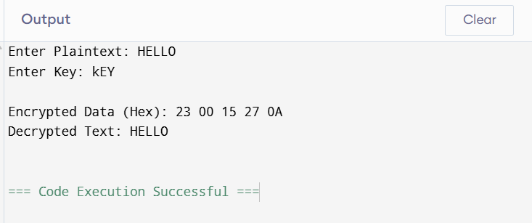
Result
The DES encryption and decryption process was implemented successfully in C. The plaintext was encrypted using a secret key and then decrypted back to the original message, demonstrating the working principle of symmetric-key encryption.

